BigLab 2: Styling the Personal Expense Tracker Using CSS
Objective
The objective of this lab is to apply CSS styling techniques to the HTML pages created in Lab 1. Students will design a clean and user-friendly interface by applying layout styling, colors, typography, and responsive design principles.
Expected Learning Outcomes
After completing this lab, students will be able to:
- Apply CSS selectors
- Use colors, fonts, and spacing
- Design navigation bars
- Style forms and tables
- Create card-style dashboards
- Understand basic responsive design
Task 1: Create a CSS Folder and File
Inside your project folder create a new folder:
expense-tracker
│
├── css
│ └── style.css
Then link the CSS file in every HTML page inside the <head> section:
<link rel="stylesheet" href="css/style.css">
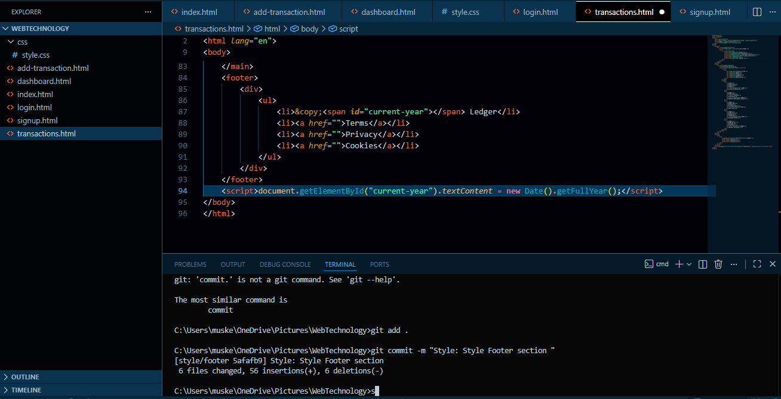
Task 2: Apply Basic Page Styling
Students must apply the following styles:
- Remove default page margins
- Set a global font
- Apply a background color
- Set text colors
Properties to use:
- font-family
- margin
- padding
- background-color
- color
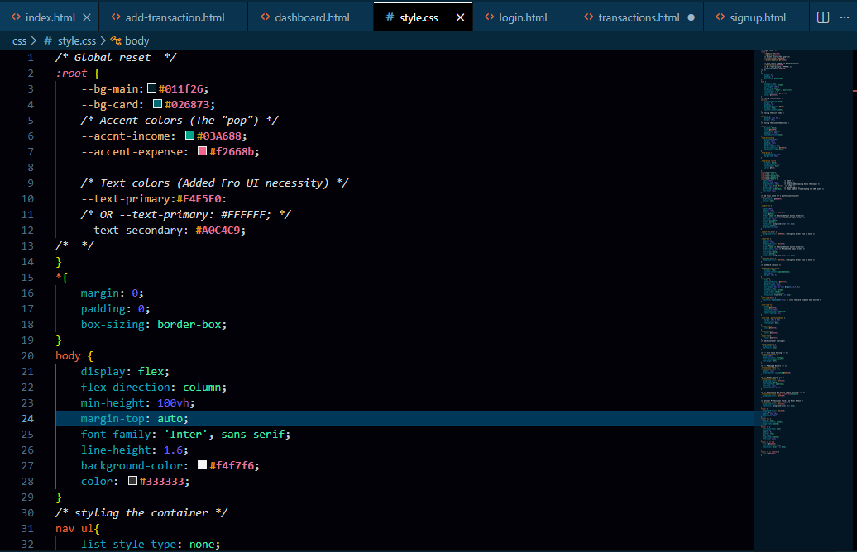
Task 3: Style the Navigation Bar
Create a horizontal navigation menu.
Requirements:
- Navigation links appear in one row
- Add spacing between links
- Change link color on hover
- Add background color
CSS concepts:
- display
- padding
- hover
- text-decoration
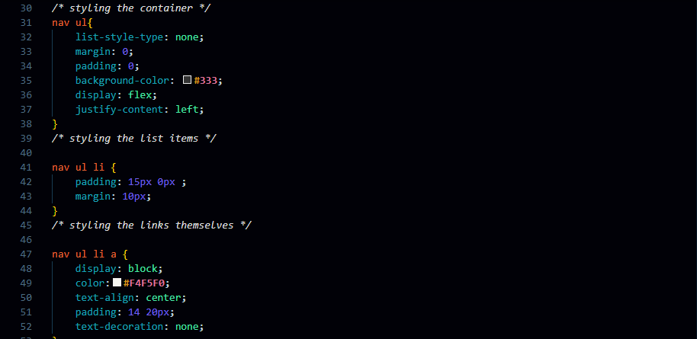
Output:
Task 4: Style Forms
Apply styling to:
- Signup form
- Login form
- Add transaction form
Requirements:
- Align form fields vertically
- Add padding and spacing
- Style buttons
- Add borders to inputs
CSS properties to practice:
- width
- border
- border-radius
- margin
- padding
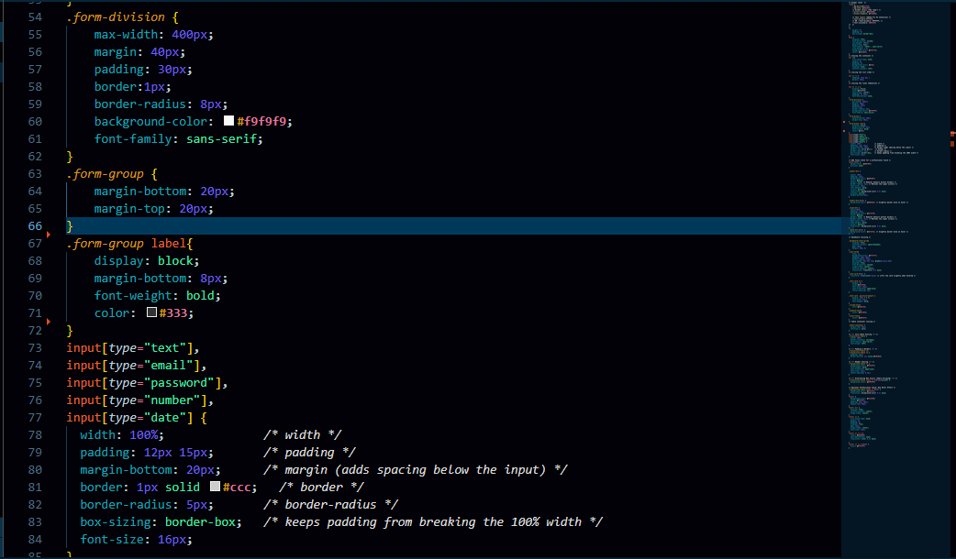
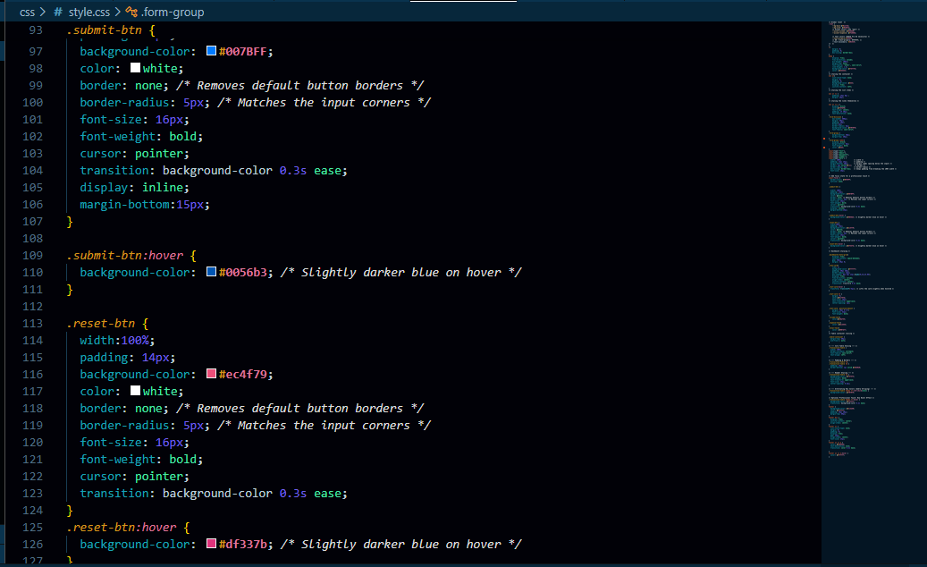
Output:
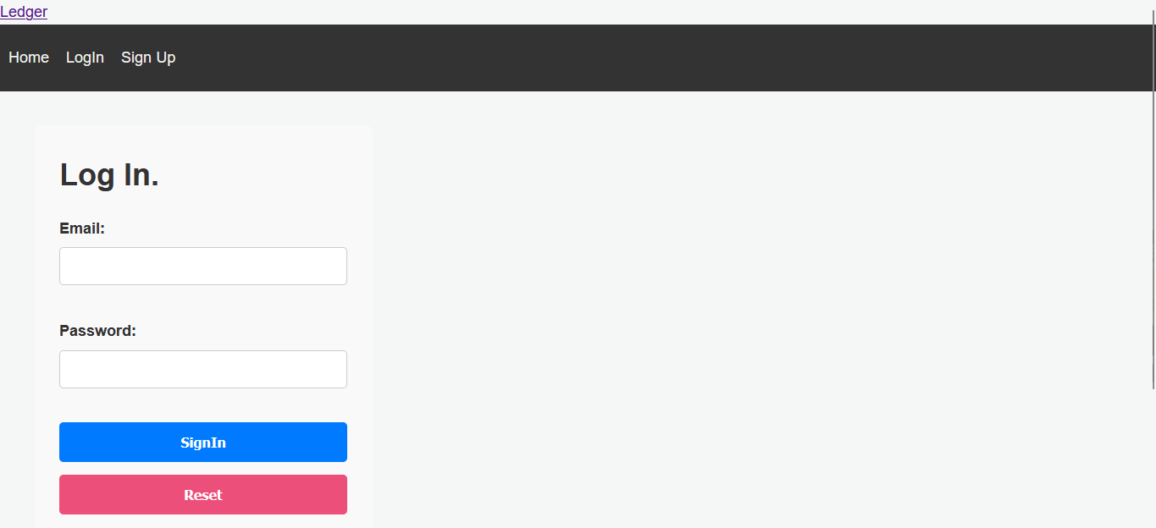
Task 5: Style the Dashboard
The dashboard should display summary cards for:
- Total Income
- Total Expenses
- Remaining Balance
Students must:
- Create card boxes
- Add background color
- Center the content
CSS concepts:
- display
- box-shadow
- padding
- border-radius

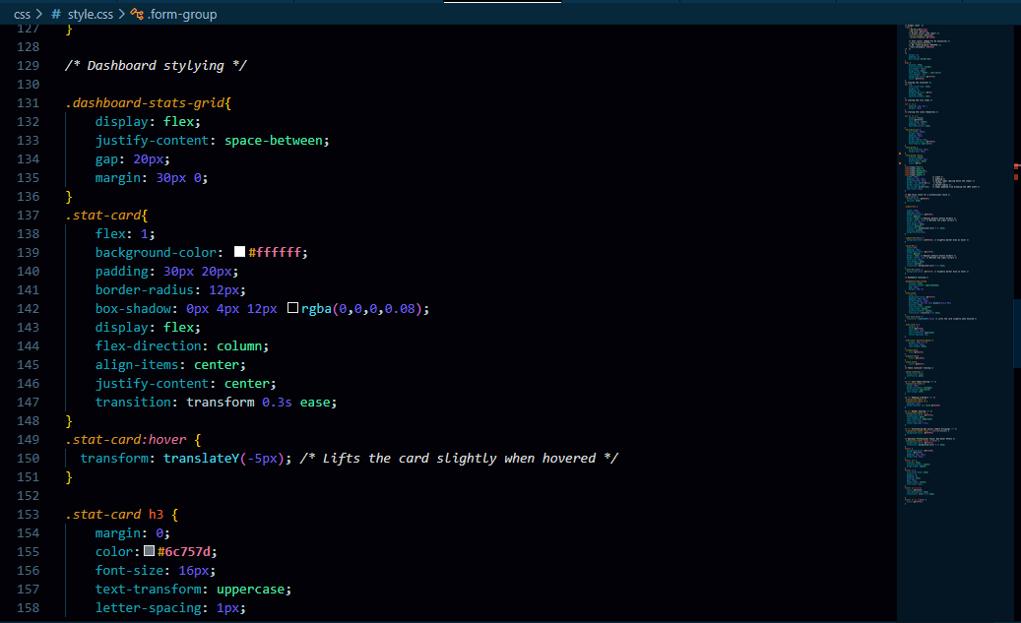
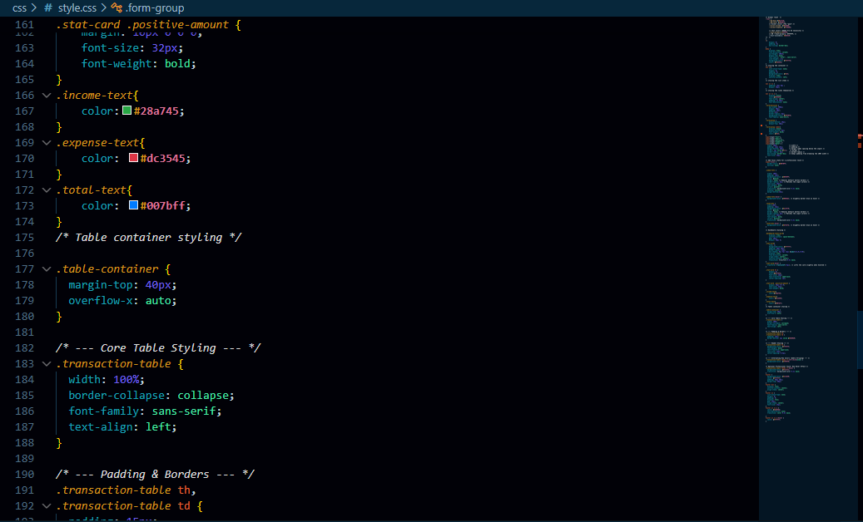
Output:
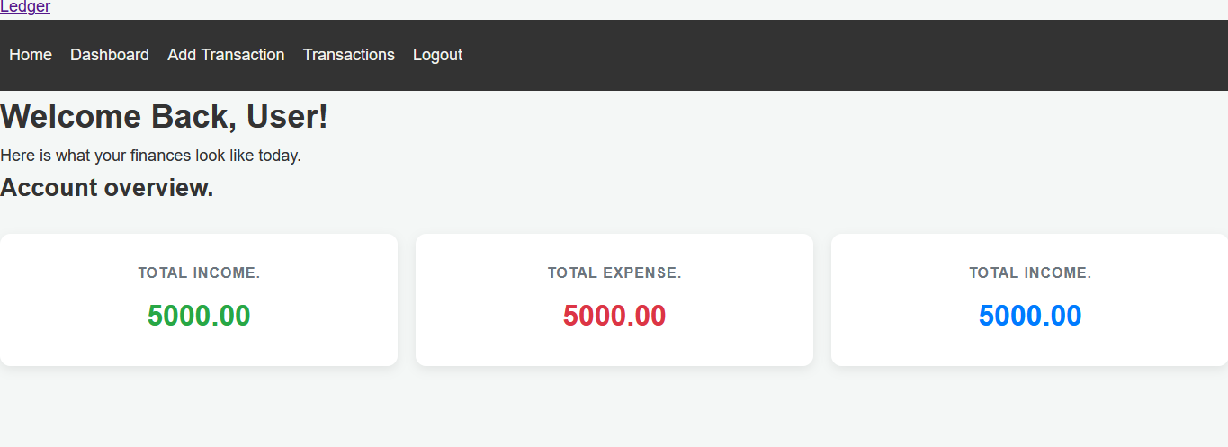
Task 6: Style Tables
The transaction history table should include:
- Table borders
- Header background color
- Padding inside cells
- Alternating row colors
CSS concepts:
- border-collapse
- nth-child
- padding


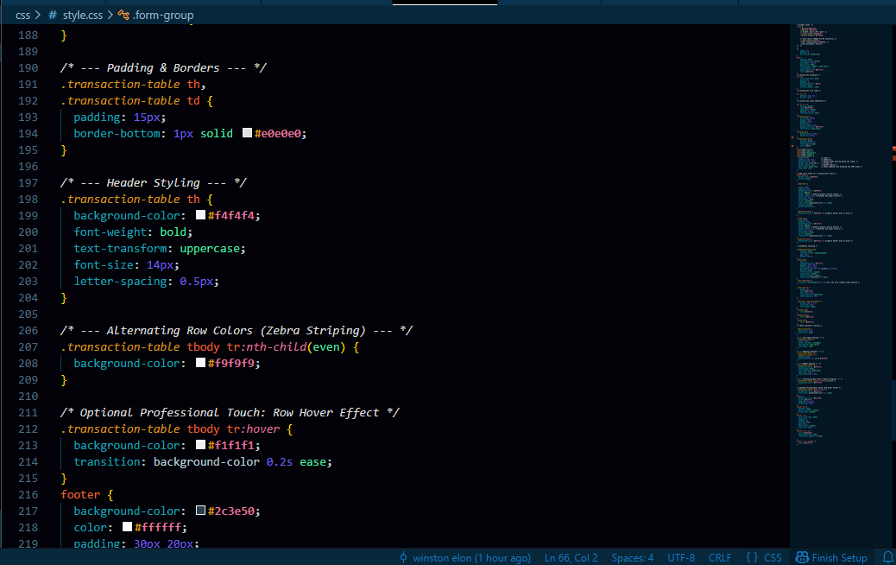
Output:
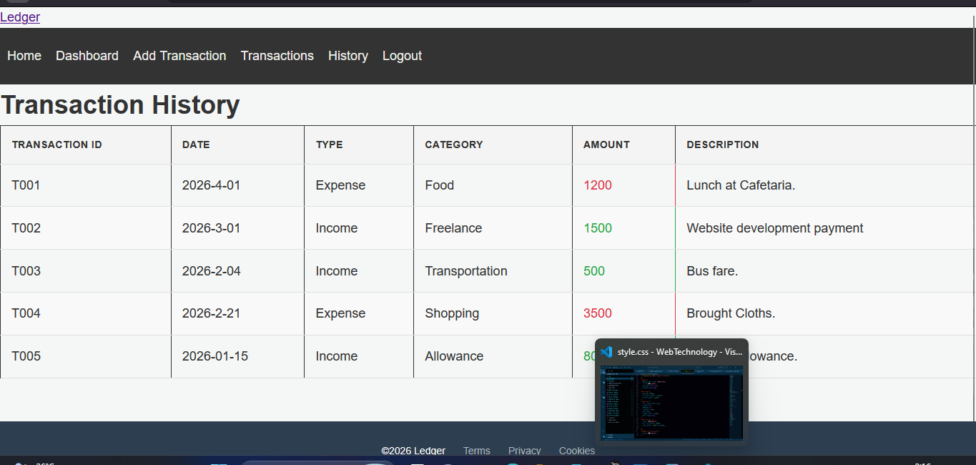
Task 7: Footer Styling
Requirements:
- Footer at bottom
- Centered text
- Background color
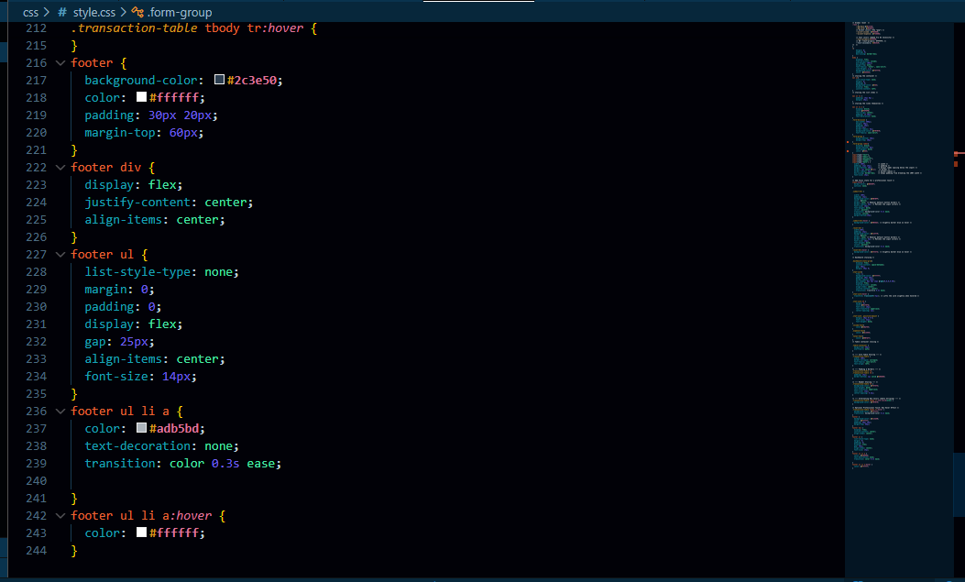
Output:
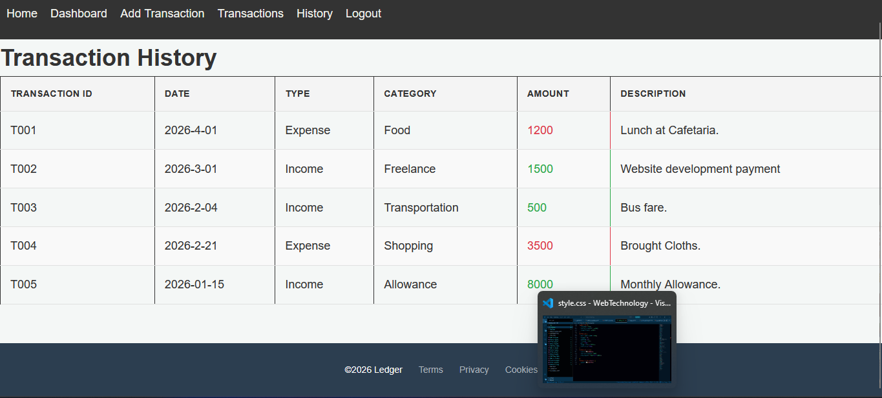
Deliverables
Students must submit:
- Updated HTML files with CSS link
- style.css file
- Screenshots of styled pages
Last date to submit: 26/April/2026 23:59 hr.

